Auto Ticket Classification using Flow Designer
5. Project Development Phase

5.1 Development Overview
The development phase implements the planned ticket classification automation in ServiceNow. The solution is designed for a school IT helpdesk where students and teachers create support tickets for common issues such as Wi-Fi problems, projector failures, password or login problems, and slow computers. The main automation component is ServiceNow Flow Designer. The flow evaluates the Short Description of a newly created ticket and updates the Category and Subcategory according to predefined keyword conditions.
The development is implemented as a no-code workflow. The ticket table contains structured fields such as Caller, Category, Subcategory, Short Description, Description, State, Assigned Group, and Assigned To. Category and Subcategory are configured as dependent choice fields so that the subcategory options are related to the selected category.

5.2 Main Development Activities
- Create and configure the ticket table required to store IT support records.
- Create the required fields and configure their data types and choices.
- Configure the dependency between Category and Subcategory.
- Create the Auto Classify School IT Tickets flow in Flow Designer.
- Configure the Record Created trigger with Category as empty.
- Create conditional branches for Wi-Fi, Projector, Password/Login, and Slow/Hanging issues.
- Update Category and Subcategory automatically based on the matching condition.
- Configure an email action to notify the Caller after ticket classification.
- Save and activate the completed flow.

5.3 Ticket Classification Logic
Input keyword / issue | Category | Subcategory
WiFi / Network | Network | Wi-Fi
Projector / Hardware | Hardware | Projector
Password / Login | Access | Forgot Password
Slow / Hanging | Performance | Slow Computer

5.4 Flow Designer Configuration
A new Flow is created under the Global application with the name “Auto Classify School IT Tickets”. The trigger is configured as Record Created on the Incident Workflow table, with the condition that Category is empty. This ensures that the automation processes a newly created ticket that has not yet been classified.
Flow Logic conditions are then added. For each condition, the Short Description field is selected using the data pill picker and the Contains operator is used to check the relevant keyword. When a condition is satisfied, an Update Record action sets the corresponding Category and Subcategory.

5.5 Development Flowchart
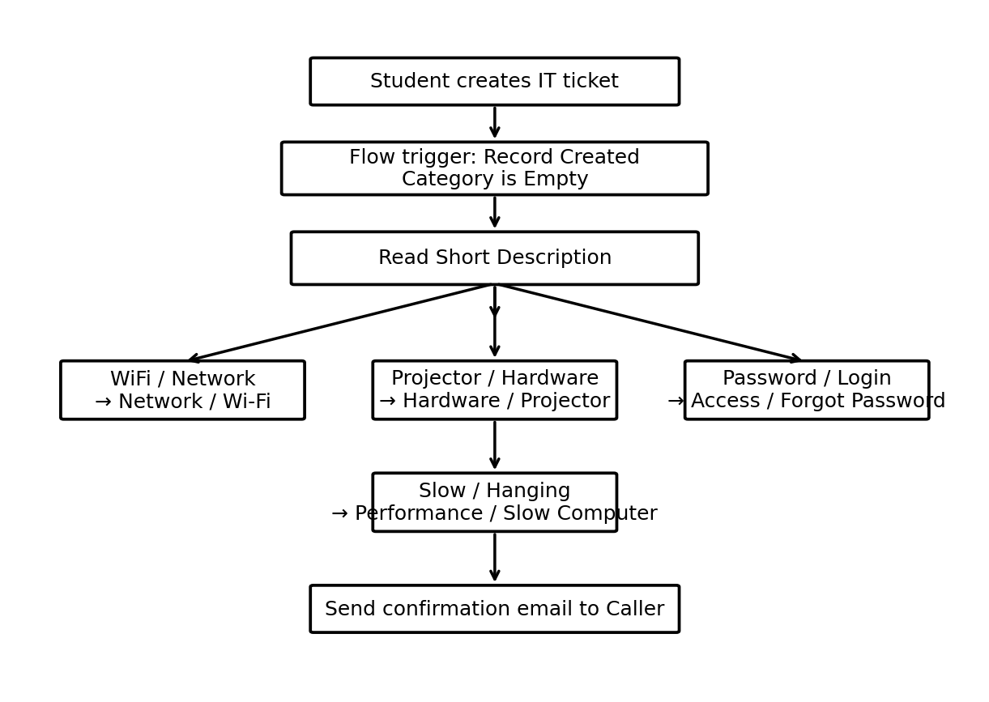
Figure 5.1: Auto Ticket Classification Flow using Flow Designer

5.6 Email Notification
After the classification process, a Send Email action is configured in Flow Designer. The email is sent to the Caller’s email address. The configured subject is “Your Request for the issue has been submitted.” A ticket confirmation message is included in the email body. This provides immediate acknowledgement that the support request has been submitted.

5.7 Activation and Expected Result
- The completed flow is saved after all triggers, conditions, actions, and email settings are configured.
- The flow is activated from the Flow Designer.
- When a new ticket is created, the flow evaluates its Short Description.
- The matching classification is written into the Category and Subcategory fields.
- A confirmation email is sent to the Caller.
- The resulting ticket contains structured and standardized classification data.

